**THE CELEBRATIONS OF LIBRARIANSHIP WEEK IN THE SCOPE OF EVENT MANAGEMENT: ANALYSIS OF THE TURKISH LIBRARIANSHIP ASSOCIATION**

**Doç. Dr. Simge ÜNLÜ**

Sakarya Üniversitesi Sosyal Bilimler Enstitüsü

[simgeunlu@sakarya.edu.tr](mailto:simgeunlu@sakarya.edu.tr)

0000-0002-0137-4210

**Doktora Öğrencisi Lütfiye YAŞAR**

Sakarya Üniversitesi Sosyal Bilimler Enstitüsü

[lutfiye.yasar2@ogr.sakarya.edu.tr](mailto:lutfiye.yasar2@ogr.sakarya.edu.tr)

0000-0001-9008-6415

**Doktora Öğrencisi Erdal BİLİCİ**

Sakarya Üniversitesi Sosyal Bilimler Enstitüsü

[erdal.bilici1@ogr.sakarya.edu.tr](mailto:erdal.bilici1@ogr.sakarya.edu.tr)

0000-0001-9386-1624

**Bağımsız Araştırmacı Feyza KARABOĞA**

[feyzakrbg@gmail.com](mailto:feyzakrbg@gmail.com)

0000-0002-1923-9965

**ABSTRACT**

The aim of this study is to determine the types of activities organised by the Turkish Association of Librarians to celebrate Library Week. The programmes celebrating Library Week organised between 2018 and 2022 were analysed using the content analysis method in the Maxqda programme, and the following result was obtained: A total of 112 codes were made in the event programme documents published between 2018-2022. The distribution of these codes according to the types and categories of events organised during the Library Week is as follows: Promotional events (f=10), Arts themed events (f=7), M.I.C.E events (f=64). The extent of these events are signature events. It can be seen that M.I.C.E events are more frequently used in the Library Week celebrations than other types of events, and most events take place in the 58th week. As the M.I.C.E event, panels, seminars and speeches were used the most. When the Kuckartz & Rädiker zeta similarity test is applied to the events organized within the scope of the celebrations, it is seen that the contents of the events show similarity. The research is unique because there are not enough studies on this subject in the literature and it is the first study to deal with the types and scale of Librarianship Week activities.

**Keywords:** Activity Management, Public Relations, Librarianship Week, Library, Reading Culture

**ETKİNLİK YÖNETİMİ KAPSAMINDA KÜTÜPHANECİLİK HAFTASI KUTLAMALARI: TÜRK KÜTÜPHANECİLER DERNEĞİ ANALİZİ**

**ÖZET**

Bu araştırmada Türk Kütüphaneciler Derneği’nin Kütüphanecilik Haftası kutlamaları için organize ettiği etkinlik türlerini tespit etmek amaçlanmıştır. 2018-2022 yılları arasında düzenlenen Kütüphanecilik Haftası kutlama programları Maxqda programında içerik analizi yöntemiyle analiz edilerek şu sonuca ulaşılmıştır: 2018- 2022 yılları arasında yayınlanan etkinlik porgramı belgeleri üzerinde toplamda 112 kodlama yapılmıştır. Bu kodlamaların Kütüphanecilik Haftası kutlamaları kapsamında düzenlenen etkinlik türleri ve kategorilerine göre dağılımı şu şekildedir: Promosyon etkinlikleri (f=10), Sanat etkinlikleri teması (f=7), M.I.C.E etkinlikleri (f=64)’dür. Bu etkinliklerin ölçeği ise imza etkinliklerdir. Kütüphanecilik Haftası kutlamalarında M.I.C.E etkinlikleri diğer etkinlik türlerinden daha fazla kullanıldığı ve en fazla etkinliğin 58. Haftada düzenlendiği görülmektedir. M.I.C.E etkinliği olarak en fazla panel, seminer ve konuşmalardan yararlanılmıştır. Kutlamalar kapsamında düzenlenen etkinliklere Kuckartz & Rädiker zeta benzerlik testi uygulandığında etkinlik içeriklerinin benzerlik gösterdiği görülmektedir. Kuckartz & Rädiker zeta benzerlik testi sonuçlarına bakıldığında 54. hafta etkinlikleri 0,84 oranıyla en çok 58. hafta ile; 55. hafta etkinlikleri 0,90 oranıyla en çok 58. hafta ile 56. Hafta etkinlikleri en çok 57. hafta ile; 57. Hafta etkinlikleri 0,78 oranıyla en çok 55. hafta ile benzemektedir. 58. hafta etkinlikleri 0,84 oranıyla en çok 54. hafta ile benzemektedir. Alanyazında bu konu kapsamında yeterli sayıda çalışma bulunmaması ve Kütüphanecilik Haftası etkinliklerinin türlerini ve ölçeğini ele alan ilk çalışma olması nedeniyle araştırma özgündür.

**Anahtar Kelimeler:** Etkinlik Yönetimi, Halkla İlişkiler, Kütüphanecilik Haftası, Kütüphane, Okuma Kültürü

**Introduction**

Turkish and in the Encyclopedia of Islam, “ Arabic ' kutub = books ' and Persian ' hane = house ' _ Location area library definitions libraries to the library is reducing. American Librarians Association of " Librarianship terms Dictionary " means " to read, to consult or research _ to do purpose with managed and organized _ book and other of materials casing was made fields " _ including more comprehensive and clear definition brought (Güneş, 2007, p. 232). According to the Atılgan (1989, p. 83) , the library word etymological in terms of When examined, the words “ library ” and “ hane ” from the combination consists of and "your books located the meaning of " place " carries.

Today, libraries are where not only printed materials but also different information sources such as CD-ROMs, video cassettes, microfiche, microfilm, online databases, and the Internet are available. Therefore, the old definition of "the place where the books are found" shows that the library concept is insufficient to define itself (Yılmaz, 2006, p. 2). Accordingly, it can be said that there are definitions problems related to the definition of the library.

Job area aspect librarianship if another _ much discipline as historical a period in developed and Corporate its structure has won. Written and printed information resources occur with the " library " organizational structure aspect of culture created by Librarianship _ your profession emerges by providing the decisive role undertaken (Toplu, 2010, p. 646).

Turkish date in terms of librarianship activities Uighurs period to stand despite the development of librarianship in the Ottoman period (Candan, 2013, p. 107). Ottoman of your state with the collapse and the republican period librarianship started. In this research, the Republican period with his Librarianship together will be taken to live the last Turkish Librarianship week events. Turkish Librarianship week, along with held activities, activity management in terms of examining Librarianship their activities detection to make is intended. This purpose, in line with the Turkish Librarianship Association's 2018-2022 years between organized by events maxqda in the program contents analysis by the method, will be examined. Study in literature librarianship week events over sufficient research absence because of importance supply.

***Ottoman in the period Libraries***

Ottoman Orhan Gazi was Iznik's first madrasah in the state in 1331. Established to be the first library setting update, There is no clarity about it. Lightning Bayezid library in the period (1389-1403) that it was founded about archive records there are. The first known foundation libraries Edirne II. Murad Darülhadisi (838/1435), Bursa Umurbey Mosque ( 843/1440 ), and Skopje İshak Bey Madrasa (848/1445) is their library (Erünsal, 1996, pp. 195–196). from the conquest Then more library was founded. Books of their collections numerically increased. Although the foundation of libraries, madrasas were a Part of it to be 16th century towards the end equivalent falling (İcimsoy & Erünsal, 2008, p. 48).

Istanbul in the 15th and 16th centuries, and Edirne found the neighborhood of libraries place 16th-century madrasah libraries at the end. In the first half of the 17th century, libraries reached other cities. Ottoman of your state libraries in terms of most rich is periods III. Ahmed (1703-1730), Mahmud I (1730-1754) and III. Osman's (1754-1757) eras coincide (Anameriç, 2006b, p. 62). Especially during the reign of Mahmud I, the library of numbers and their collections abundant undeniable a is reality. Abdulhamid, in the era the other hand (1774-1789), various personal libraries to open. III. Selim (1789-1807) and II. During the reigns of Mahmud (1808-1839), the state intellectuals in their hometown or their duties executive in the region's libraries they established known (Müşerref, 2021, p. 242).

Ottoman in your state annoyed to wealth owner people, many no owner by in mosques and various no to their institutions a or a few cabinets by putting libraries created. Library to establish power for those who are not enough, the library care donated, donated or worker their salaries to increase contribute was found (Erünsal, 2015, pp. 195–199). II. Constitutionalism national libraries during established; palace libraries confiscation and gifts thanks to has become even richer (Ateş, 2022, p. 818). 19th century with on loan does not give limitation reason with of libraries open stay times extended more service to provide (Anameriç, 2006a, p. 198). Similar to libraries, read halls also appear to have been added.

*In the republican period, libraries*

Mustafa Kemal Ataturk's people observing their revolution promised to make for to cities, made visits over there to libraries go, borrow books, and take in libraries' problems detection to do. Answer find to libraries given importance shows (Anameriç, 2008, p. 496). In the republican period, established social an institution the one which... in libraries building restoration, renovation and transport as with transactions library in the number of an increase occur has arrived and library varieties like this can be listed :

1. Ankara High Agriculture institute library

Türkiye's and the West scientific their works Ankara Yüksek, the first library to host Agriculture institute It is the library. From Germany, 20,000 volumes received book donations with the created library, and more than 50,000 in the late 1930s book number reached. Türkiye Republic's first library being of the property well desk Jewish German-born architects by German architecture sample by taking to be done as of Western architecture also with attention (Aşkın, 2017, p. 109).

1. Turkish History institution library

Türkiye's republic of science and culture date in terms of importance bearing Turkish History Institution, Turkology research from what you do own specialization in the field to be executed research for the primary source central aspect own to the library owner has been (*Türk Tarih Kurumu Başkanlığı Kütüphanesi*, 2022).

1. Turkish Tongue institution library

Ataturk scientific your studies however durable a with language can be done emphasized and the National Struggle in the year's tongue their work neglect did not, Turkish Tongue Institution has established. Turkish Tongue institution The library of the institution purposes in line with service (*Türk Dil Kurumu*, 2022).

1. Türkiye Grand National Assembly Library

Ottoman in the State, an institution within the established and republic open during _ to stay continue have done the one which... Türkiye Grand National Assembly library, with libraries relating to problems, hand taking any law, statute, official newspaper as own to specialization specific works casing (Çakmak & Tırnavalı, 2020, p. 17).

1. Turkish quarries Libraries

1912-1931 between active a way Librarianship and publishing he has done. Turkish quarry libraries Only printed, not audiovisual, materials to the public open a way into service presented (Akyüz, 1986, p. 201). These services Besides the foreign in language term broadcasts Turkish their translations acquirer and on loan do not give certain principles of connecting to the library to be taken your books in the selected bibliography and broadcasting from catalogs take advantage of modern librarianship _ to the understanding owner are libraries (Karaer, 1990, p. 55).

1. People's Houses Libraries

Formal in 1932, the establishment, despite its origins in Turkish to the Quarries (Özdemir & Aktaş, 2011, p. 236). People's Houses were founded, period; the people needed to be heard with books together. Most value culture centers on location (Karpat, 1974, p. 72). Community home Libraries of the people demands with formed, institutions ring to deliver they want books around here to send with wealth has won.

1. Bay Institutes Libraries

After the Republic's social identity configuration from their work, the most crucial somebody Bay of Institutes is the establishment. Bay's new regime of the Institutes defended society civilization to the level of transport leadership to make missions there (Kucuktamer & Uzunboylu, 2015, pp. 393–394). Bay of Institutes this their mission in its place in bringing at the institute librarianship activities in 1944. started and ended in 1950 (Keseroğlu, 2005, p. 38).

1. National Library

abroad after the republic. Education to send many youngish somebody Adnan Ötüken, National Library's establishing most has a large share. Ötüken, National Education in 1936 Ministry by opened exam by winning librarianship education receive about to Germany gone (Ötüken, 1957, p. 6). Europe in their countries of the National Libraries in our country not to be lack aspect described and national culture their research possible make this _ purpose related all works and documents a together collect, science, art, and culture their research facilitate target with the National Libraries opening up for required my name threw (Şenalp, 2008, pp. 445–446). National Libraries, Bibliography in the Center Türkiye Bibliography and Türkiye Articles Bibliography as many bibliographies, the library of catalogs getting ready published are libraries (Başbuğoğlu, 1972, p. 41).

1. University Libraries

in universities course level librarianship your training to be given of the start next professional librarianship job to status got (Çelik & UÇAK, 1993, pp. 120–121; Rukancı & Anameriç, 2017, p. 74). University of libraries development of society in the structure with transformations shape received and German and American science of your people under the influence remained (Üstün, 1977, p. 229).

1. Mobile / Mobile Libraries

Mustafa Guzelgoz in Urgup donkey mule _ and on horseback wood with chests given mobile librarianship service with social id to convert individual contribution provided (Ersoy, 1962, p. 114). People's Houses shut down with distributed books casing the library _ created and more. Then the villagers acquired the library of the people at their feet to take duty, and women's libraries were visited to conduct various activities(Ersoy, 1963, p. 37).

1. Personal Libraries and Special Research / Specialization Libraries

in the republican period, intellectual

persons' libraries formed. Personal libraries inside donated or bought taken by libraries casing have been into service offered outside, auctions or various initiatives abroad with _ some are transferred, distributed and destroyed. In Türkiye, second-hand booksellers in the development personal of libraries are an essential contribution. Bookkeepers were formed from libraries, taken away, and sold to the books brokerage (Çakın, 1991, pp. 49–50).

1. National Library

in 2015, National Library started Türkiye's most large library feature carries. Beştepe Presidency Kulliye in Location National Library, Presidency _ Administrative Works Presidency within the Support and Financial Services General Directorate, Libraries Apartment to the Presidency connected aspect service. From the National Library, use for e-Government over membership can be created or TR Identity Card / TR Identity Card number ( foreign nationality at the main door with individuals ) member aspect login available (*Kütüphaneler ve Yayımlar Genel Müdürlüğü*, 2022).

*In libraries with the public Relationships Applications*

with the public relations, institutions, and publics between interactive communication, business union, acceptance and the deal continuing an Administration is the function. This administration function of institutions conscience aspect being described together corporate goodwill _ emerge to be placed for long term and couple directional Contact its activities (Işık & Akdağ, 2009, pp. 21–23). Therefore this Contact activity To life was passed on from institutions. One is libraries. libraries with the public relationships to their applications, it is increasingly influential in giving available positive of the air preservation. In addition to this benefit with the public relationships, in libraries failing your directions detection by improving for a Contact into the bargain aspect is used (Karadeniz, 2010, p. 88). Conclusion as; libraries Corporate of your services in the introduction of readers their demands in determining and this requests in line with service its planning in creating with the public from relationships benefits.

Influential and of Librarianship in the development of the public your needs welcome and of Librarianship their values with the public TRUE way transfer with the public your relationships role increasingly significant (Çağlar & Yılmaz, 2007, pp. 8–9). It depends as; in libraries with the public relationships applications of the public, your trust win wishes _ understand and interpretation and dialogue creating important a is the key (Akman, 2009, p. 388). Successful librarianship in his approach of the people requirement for resources productive use of basis is taken. Therefore, a couple directional with the public relationships approach should be adopted in librarianship.

According to Wolfe (1997, p. 4), librarianship of your values ring library, adopting programs and developing your service with the public relationships to their applications Location is given. In addition to these applications in the public negative, your attitudes away in the removal with the public relationships from their applications effective in a way are used (Akkaya, 2013, p. 172). In short, user-focused, favorable to the image owner and goodwill _ approach adopted a modern in Librarianship with the public relationships of applications approach indispensable a is the item.

Libraries, public relationships their tools use information its function in its place to reflect various events and participation incentives. _ In this context, in libraries with the public, your relationships activities and this your activities importance this way can be sorted:

**Figure 1:** In Libraries with the public, Your relationships Activities and These Activities importance

**Source:** (Hazarika, 2021, pp. 125–126; Keten, 2008, p. 113)

In libraries with the public relationships activities in the scope of library policies with the public by telling drying against prestige and reliability creates. It depends on the library with people between bonds by establishing information on the formation contribution provided. Therefore libraries from sources take advantage of incentive by being TRUE information TRUE on the ground access to society is gained.

***Library week and with the public Relationships application Aspect Activity Management***

In Türkiye, people go to libraries for library resources to use an incentive for the purpose; since 1964, this Last Monday of March every year, _ the day " Library as " week " has been celebrated. Library in weeks panels, conferences, seminars, and symposiums being organized; readers book and with the authors bringing together fairs are organized; award-winning competitions and draws (*Kütüphaneler ve Yayımlar Genel Müdürlüğü*, 2022).

" Library Celebration of the Week with relating to Library your week Celebration Regulation, TR Official Newspaper 17625, on March 6, 1982, prepared the purpose of your celebration, how and where that you can by the way public provisions contains. To the regulation by your celebrations responsibility and management, Culture and Tourism to the Ministry connected Libraries and Publications General Directorate with Turkish Librarians Association. This regulation purpose of the Constitution in line with cultural development democratic by ways to realize contribute found libraries citizens closely their recognition by providing more lots to take advantage of recruitment for the purpose celebrated ' Library in the week to do activities to determine ." (*Kütüphane Haftasını Kutlama Yönetmeliği, T.C. Resmi Gazete*, 1982).

Formal newspaper in content in the center and upstate to do celebrations for the fundamentals and criteria. This way, the Location takes :

a) In the Center :

1. Library weeks, General by the directorate, library and librarianship their issues hand area on matters congress, symposium, etc. is regulated. All three of these meetings per year at an international level to be done for external countries reputed library of the authorities Invitation to be is worked.

2. One last year inside retired the one which... and in libraries 20 years worked the one which... to librarians one by one plate given.

b) In the countryside :

1. To the Ministry connected all new publications in libraries to readers introductory exhibitions are arranged,

In the 2nd Exhibition, Atatürk and to their reforms belonging book and term your publications display for an “Atatürk Corner ” leaves,

3. Library staff with a meeting by making will be exhibited your books selection of the exhibition arrangement shape, opening program and week during will be given conferences it is decided and at the exhibition will be assigned employee detection is done,

4. Exhibit will be held your place cleaning, arrangement and your posters to the preparation a week previously starts,

5. Exhibition to the opening of the library located your province protocol list in consideration by keeping concerned Invitation is done,

6. First and middle graduates your schools to the exhibition visit be programmed by preparing relating to places sent,

7. Exhibition, very purposeful hall found in libraries this in the hall if reading _ from the halls take advantage of utilizing is prepared . from reading rooms utilization during the reader of your services not to be interrupted Caution is done,

8. Local from the possibilities using ( local newspapers, municipality speaker, TRT, etc.) located to the environment week with Relating to announcements is done,

9. Library and book read my subjects working articles by preparing local in the newspapers their publication is provided,

10. Library around found other with organizations partnership by making necessary material (film and slide machines, films , posters, etc.) and week during trainer and cultural film and slide shows is arranged,

11. Week during in the library, ( building accessible if not appropriate the one which... other an on the ground ) around found other education and culture with their organization's partnership by making of the week the importance of will indicate conferences is given,

12. Surrounding schools, other education, and cultural organizations with partnership buildings white library, and with book relating to various organizing competitions ( painting, composition, poetry, etc.) is provided,

13. Above stated activities and exhibition preparations for the studies two months ago are started.

Library in the week held your activities prestige increase, more interest wake purpose with the public relationships from their applications. In this context Library, week activities planning and managed process with the public relationships specialists by activity components ( management, program, participant ) and installation ) suitable should be organized as (Getz, 2000, p. 16). with the public, they are related of experts organized by this event a country or the region will affect mega event if the level aspect is characterized . in the media wide in proportion Location covering events significant event aspect while being named clear a theme around taking shape events qualified events aspect is defined. A place-associated events signature activity aspect while editing special a moment to celebrate organized for _ celebrations notable activity aspect classified (Van Der Wagen & White, 2002, pp. 7–10). These event types affect areas differently because own in separate activity culture has developed can be said.

Events, community cultural, religious, or seasonal _ celebrations, including editable festivals. This event In addition to the concept; of notable cultural contributions, provides dance, cinema, theater, concerts, and competition (Özkanal, 2014, p. 15; Ziakas, 2013, p. 93). In addition to the scientific or work the world appeal, M.I.C.E events are also organized. M.I.C.E events include fairs, congresses, meetings, commercial shows, panels, and workshops as events Location takes (Arcodia & Robb, 2000, p. 156; Şahin & Karakullukcu, 2019, p. 249).

Library week, events in the scope of held your activities content when examined held events this way can be grouped :

**Figure 2:** Librarianship week Events

**Source:** (Benefiel et al., 1992, p. 86; Karadeniz, 2013, pp. 223–224)

To Yılmaz According to (2010, pp. 133–139), Library in the week to do your activities to scale increasingly is essential. Therefore this event, libraries, and information services in terms of in society an awareness if not created, request increase if not available, libraries your presence either will be questioned or virtualized. _ For this reason, the Library week to do your activities contents, " awareness to the purpose of " creation " appropriate being condition because you carry quite is critical (Yılmaz, 2003, p. 23). Mission outside all types made activity aim to the audience to reach an obstacle. _ your purpose assimilation and Formal in the newspaper materialized celebration to the fundamentals loyal stay; with the public relationships tools design with media communication etc. aim in line with should be planned (Aladağ, 2019, pp. 135–136).

**Method**

In this research Turkish Librarianship Association by Librarianship in the week held events contents analysis by the method scrutinized. Contents analysis, coding, and coded data analysis do not process by being together a subject on you trends detection to make for (Ültay , E., Akyurt, H., & Ültay, 2021, p. 190; Westbrook, 1994, p. 248). This research on the method's primary principles of systematicity, objectivity, and generality (Hepkul, 2002, p. 4) .. Moreover, acording to Lune and Berg (2016, p. 189) wrote text contents to the mother while coding code. The theme will form seven elements following is like :

**Figure 3:** Content In your analysis Counting Required Elements

Library week activities maxqda in the program contents analysis by the method prudence this study research questions this way sortable

* Librarianship week at the celebrations used activity types. What are they?
* Librarianship in the week most used activity Type which is it?
* Librarianship week celebrations which activity to scale enters?
* Librarianship week activities content similarity does it show?

**Results**

In this study, the Turkish Librarianship Association's 2018-2022 years between Librarianship week celebrations are intended to the organized by events analysis. This purpose is in line with celebration programs maxqda in the program contents analysis by the method by examining get made Results is as follows :

Events to types and to categories by when grouped activity types promotion activities, artistic events, and M.I.C.E events as subheadings _ separated. Activity scale if signature activities subtitle _ there are. These themes and sub-themes frequency distribution table the following is like :

**Table 1:** LibraryHousekeeping week Code matrix Frequency Table

|  |  |
| --- | --- |
| Code themes | Code Frequencies |
| 1) Activity Types |  |
| a) Promotion Events | 10 |
| b) artistic Events |  |
| Concert | 6 |
| Cinema/ Documentary notation | 1 |
| c) MI CE |  |
| Conference | 5 |
| Panel | 20 |
| Seminar | 17 |
| Workshop | 1 |
| Speeches | 13 |
| Prize Ceremonies | 8 |
| 2) Activity scale |  |
| Signature Events | 31 |
| Total | 112 |

Activity types sub-themes of the theme and frequency distribution this as : Promotion activities (f=10), Art events theme (f=7) concert (f=6) and documentary / cinema notation (f=1) sub- themes is leaving . M.I.C.E events (f=64) theme conference (f=5), panel (f=20), seminar (17), workshop (f=1), speeches (f=13) and prize ceremonies (f=8) sub- themes . is leaving. Activity scale aspect signature activities (f=31) were arranged.

**Table 2:** Library week Events Code matrix Table

|  |  |  |  |  |  |
| --- | --- | --- | --- | --- | --- |
|  | **Activity Types \ Promotion Events** | **Activity Types \ Artistic Events** | **Activity Types \MI CE** | **Activity Scale \ Signature Events** | **TOTAL** |
| Program 58 | 0 | 3 | 21 | 11th | 35 |
| Program 57 | 9 | 2 | 12 | 0 | 23 |
| Program 56 | 0 | 1 | 13 | 0 | 14 |
| Program 55 | 1 | 1 | 10 | 12 | 24 |
| Program 54 | 0 | 0 | 8 | 8 | 16 |
| TOTAL | 10 | 7 | 64 | 31 | 112 |

Code matrix table when evaluated promotion events Week 55 and 57 only at events Location by taking frequency is (f=10). Art events week 54 outside the programs Location received is seen, and frequency is (f=7). M.I.C.E events all celebrations in their programs Location received is seen. M.I.C.E events frequency is ( f=64) . Signature events in the 56th and 57th Programs Location not given is seen, and this activity of the category frequency is (f=31).

**Figure 4:** Librarianship Week 2018 54th Week Events

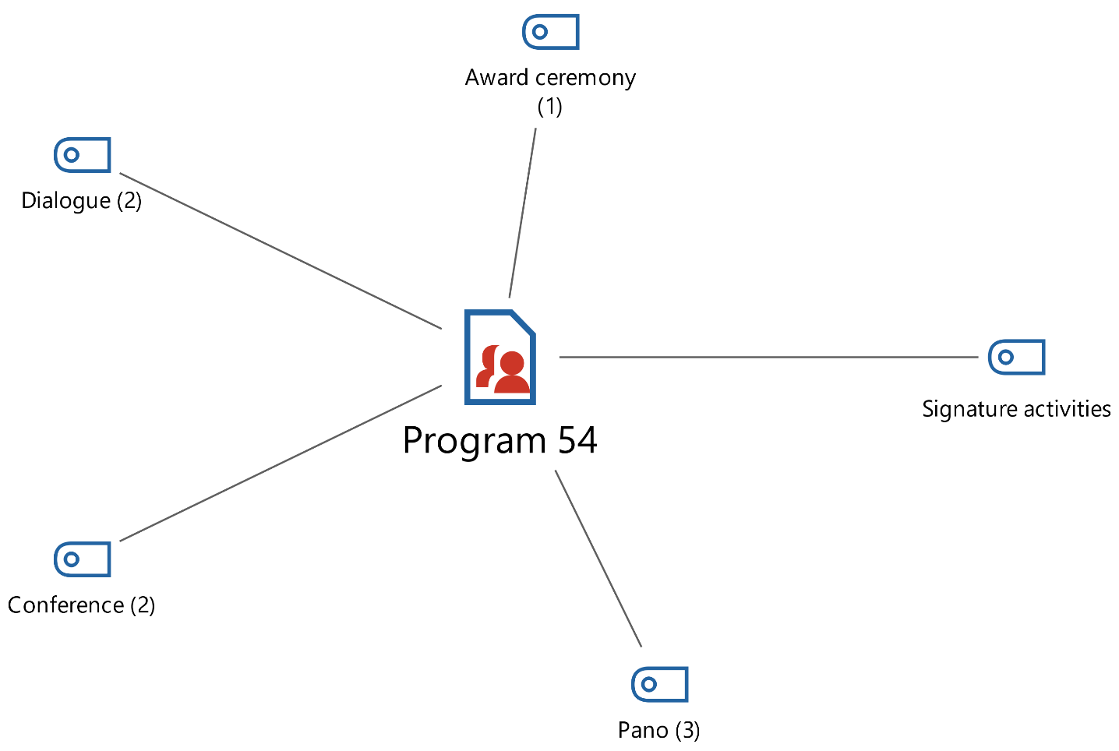

54th-week events within the scope of MIC E events panel, conference, speech, and prize ceremony made is seen. Your events frequency distribution as follows : Panel (f=3), conference (f=2), speeches (f=2) and pay ceremony is (f=1). In addition to these activities, signature activities (f=8 ) are observed.

**Figure 5:** Librarianship Week 55. Week of 2019 Events

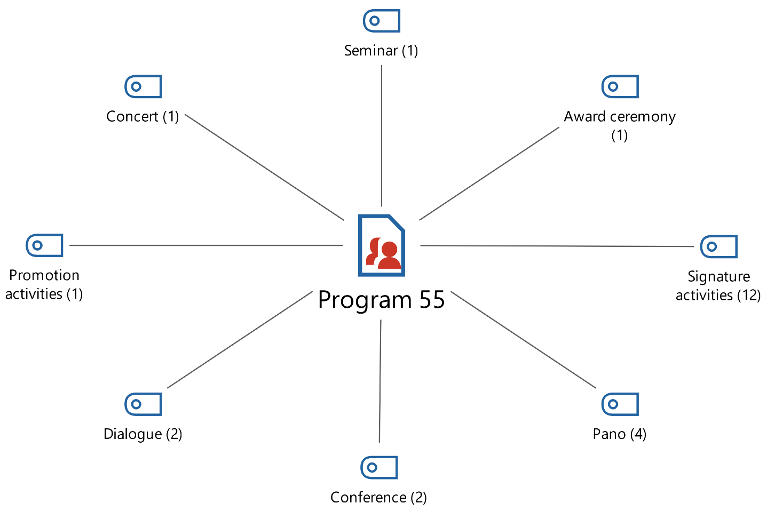

Week 55 events in the scope of promotional, artistic, and M.I.C.E events together used seen. Hold your activities frequency distribution as follows: Promotion activities (f=1), Artistic activity aspect concert is (f=1). M.I.C.E events panel (f=4), conference ( f=2), speeches (f=2), seminar (1) and prize ceremony is (f=1). Signature your activities frequency and (f=12).

**Figure 6:** Librarianship Week 56 Week of 2020 Events

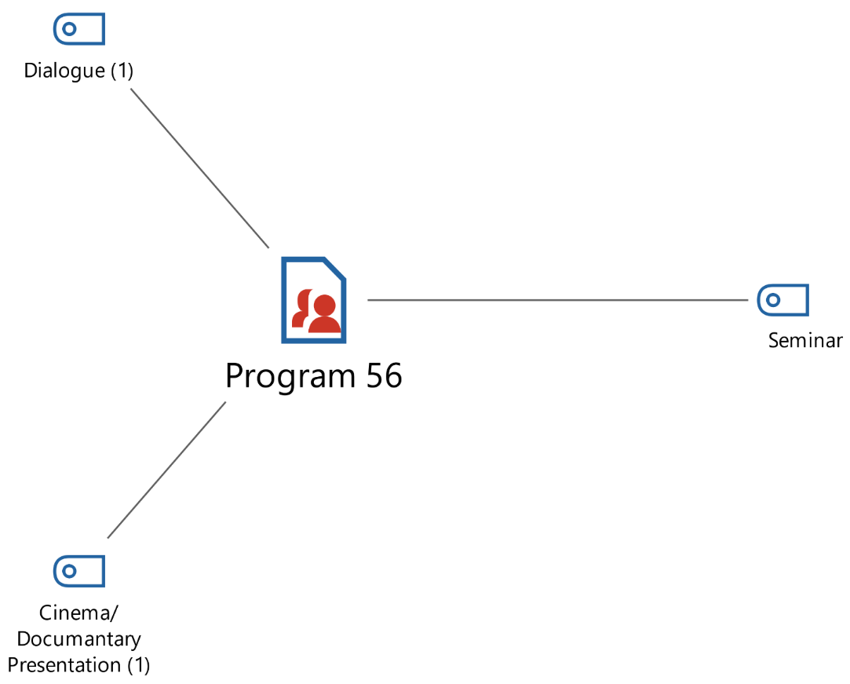

56th-week celebrations within the scope of M.I.C.E and art your activities together used is seen. 56. Week at the celebrations, your activities frequency distributed as follows: artistic events in the scope of cinema/documentary its notation is (f=1). M.I.C.E events if covered speeches (f=1) and seminar (f=12).

**Figure 7:** Librarianship Week of the Year 2021, 57th Week Events

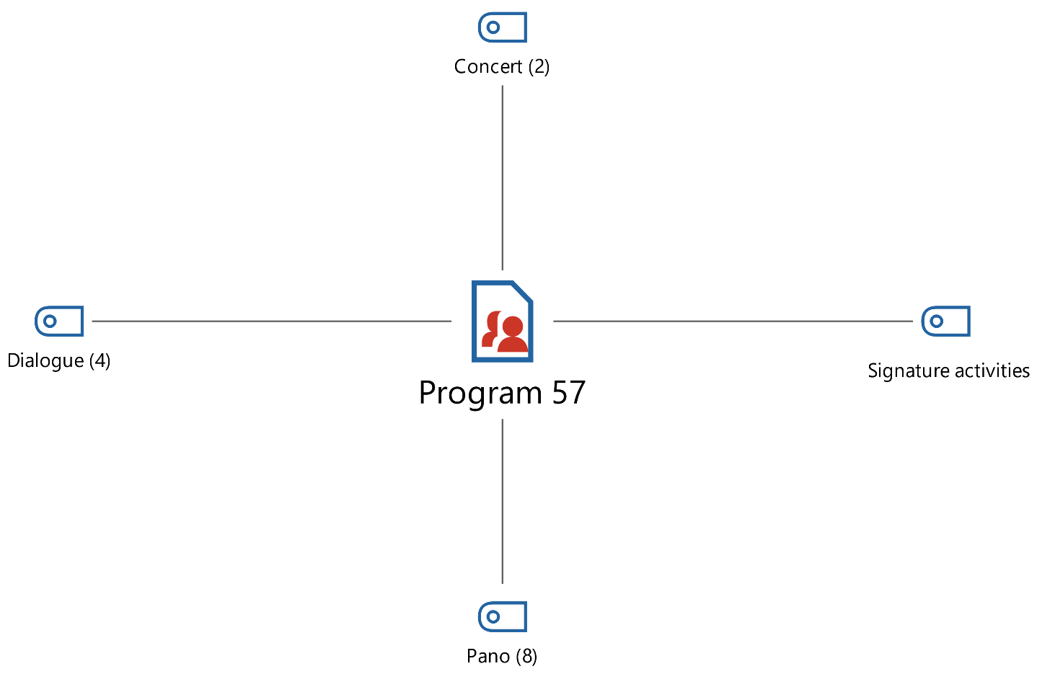

57. Week events in the scope of promotional, artistic, and M.I.C.E events. Of these activities, the frequency distribution is as follows: artistic events in the scope of the concert (f=2 ) were organized, while M.I.C.E events in the framework of speeches (f=4) and panels (f=8) were arranged. In addition to these activities, promotion activities ( f =9) have been passed.

**Figure 8:** *Librarianship Week 2022 58th Week Events*

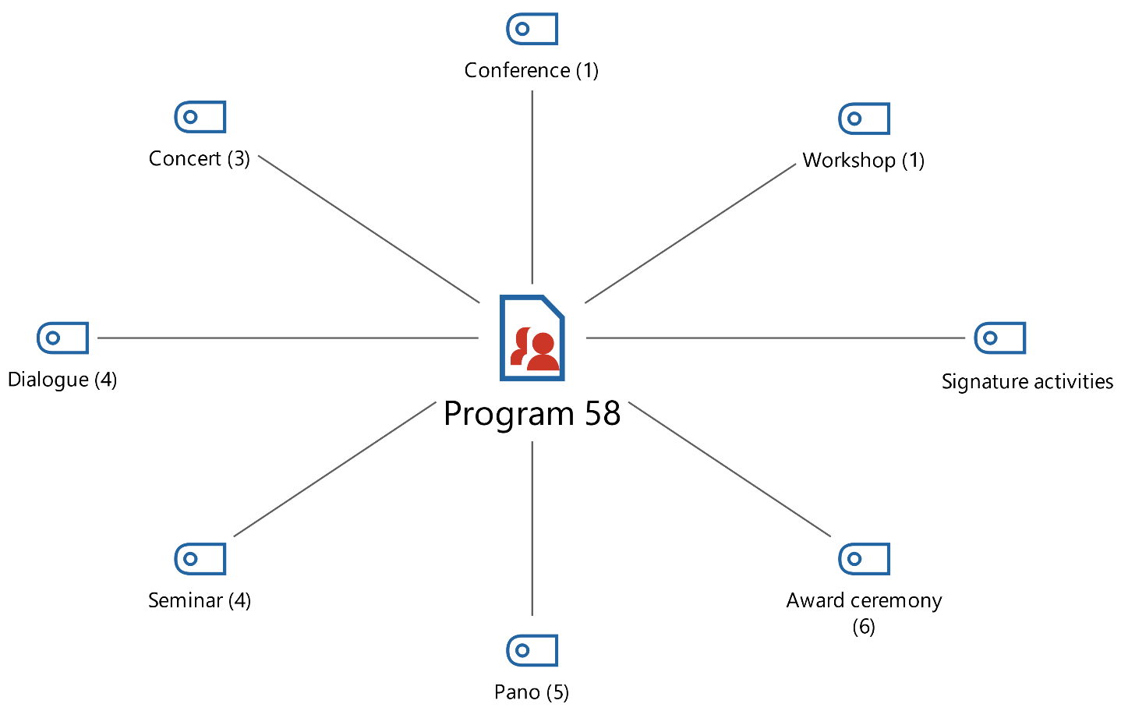

58. Week events in the scope of art and M.I.C.E events edited. of these activities frequency if distributed this as artistic activity in the framework of held M.I.C.E events while the concert (f=3) aspect conference (f=1), Workshop (f=1), Speeches (f=4), seminar (f=4), and panel (f=5 ). In addition to these events, signature activities are (f=11 ).

**Table 3:** Library week Events Kuckartz & Radiker zeta Similarity test Table

|  |  |  |  |  |  |
| --- | --- | --- | --- | --- | --- |
| **Document name** | **Program 58** | **Program 57** | **Program 56** | **Program 55** | **Program 54** |
| Program 58 | 1.00 | 0.65 | 0.56 | 0.90 | 0.84 |
| Program 57 | 0.65 | 1.00 | 0.67 | 0.78 | 0.69 |
| Program 56 | 0.56 | 0.67 | 1.00 | 0.56 | 0.60 |
| Program 55 | 0.90 | 0.78 | 0.56 | 1.00 | 0.84 |
| Program 54 | 0.84 | 0.69 | 0.60 | 0.84 | 1.00 |

Quartz & Rädiker zeta similarity test table 54 weeks when analyzed activities with a rate of 0.60 most less than 56 weeks events with while similar to the most with 0.84 very 58 weeks with similar. 55th-week activities with a rate of 0.56 most less than 56 weeks events similarly, with a ratio of 0.90 most every 58 weeks with similar. 56. Week events with a ratio of 0.56 most less than 58 weeks events with a rate of 0.67 most very week 57 with similar. 57. Week activities with a rate of 0.65 most less than 58 weeks events while similar to the most with 0.78 very 55th week with similar. 58th-week activities with a rate of 0.56 most less than 56 weeks events while similar to the most with 0.84 very 54th week with similar. Therefore Kuckartz & Rädiker zeta similarity test table eyelash before when taken your activities large in the proportion each other resembles is seen.

**Conclusion**

In this research, Turkish librarianship Association's 2018-2022 years between organized by Librarianship week events maxqda in the program contents analysis by examining this to the results reached: 2018- 2022 years between published activity program documents on 112 encodings in total made. These encodings activity types and categories by distributed as Promotion activities (f=10), Art events theme (f=7) is M.I.C.E events (f=64 ). These themes eyelash before " Librarianship " week at the celebrations used activity types what are they ?" research the question is has been answered.

Librarianship in the weekly activity of types frequency distribution hand, when taken art events theme, is (f=7). In this theme concert (f=6) and documentary / cinema notation (f=1) sub- themes is leaving . promotion activities are (f=10). Another _ theme of M.I.C.E events is ( f=64 ). This theme includes panel (f=20), seminar (17), speeches (f=13), award ceremonies (f=8) conference (f=5), and workshop (f=1) sub- themes is leaving . hand received theme and frequencies when analyzed _ more used activity M.I.C.E events of its kind are detected. Thus, the question response is given in the " Librarianship in the week most more used activity Type which one? " research.

Moreover, activity scale aspect signature activities (f=31) were arranged. It depends on " Librarianship week celebrations. Which activity to scale enter ?” The question has been answered in my research.

Library week events to weeks by evaluated at the 54th Week art event (f=1), M.I.C.E events (f=8), signature be active (f=8) about to 16 events in total edited. At Week 55 promotion activity (f=1), artistic event (f=1), M.I.C.E event (f=10), signature be active (f=12) 24 events were organized . _ At Week 56, art events (f=1) and M.I.C.E events (f=13 ), about 14 activities, have been arranged. 57th week at events promotion activity (f=9), artistic activity (f=2), and M.I.C.E activity (f=12 ) about to 23 events in total To life has been passed. Fifty-eight weeks at events art event (f=3), M.I.C.E event (f=21), signature have activities (f=11) 35 events _ is planned. In this context, most more at week 58 of the event arranged is seen. Of these activities contents, Kuckartz & Rädiker zeta similarity more than 60 % tested similarity it shows is seen. Therefore, the " Librarianship week activities content similarity Does it show ?" research question as yes has been answered.

Conclusion for 58 years held Librarianship week at the celebrations promotional, artistic and M.I.C.E events Location is given. From these events, most More M.I.C.E events used are seen. M.I.C.E event aspect most more panels, seminars, and conversations benefited from is seen and held your activities signature activity nature he carries detected.

**References**

Akkaya, M. A. (2013). Halk kütüphanelerinde halkla ilişkiler ve Narlıdere İlçe Halk Kütüphanesi örneği. *Türk Kütüphaneciliği*, *27*(1), 168–179.

Akman, İ. (2009). Ulus Halk Kütüphanesi ve halkla ilişkiler uygulamaları. *Türk Kütüphaneciliği*, *23*(2), 386–392.

Akyüz, K. (1986). Türk Ocakları. *Belleten*, *50*(196), 201–228.

Aladağ, H. H. (2019). In Our History of Library after 1960s; Analysis of Some “Library Week” Posters in The Framework of Roland Barthes’s Semiotics Method. *International Journal of Social and Educational Sciences*, *6*(12), 133–147.

Anameriç, H. (2006a). İstanbul Köprülü Yazma Eser Kütüphanesi. *Türk Kütüphaneciliği*, *20*(2), 195–202.

Anameriç, H. (2006b). Osmanlılarda Kütüphane Kültürü ve Bilimsel Yaşama Etkisi. *Osmanlı Tarihi Araştırma ve Uygulama Merkezi Dergisi OTAM,* *19*(19), 53–78.

Anameriç, H. (2008). Belgelerle Atatürk ve kütüphaneler. *Atatürk Araştırma Merkezi Dergisi*, *24*(71), 487–514.

Arcodia, C., & Robb, A. (2000). A future for event management: A taxonomy of event management terms. *Events Beyond*, *6*(4), 154-160.

Aşkın, U. (2017). Ankara Yüksek Ziraat Enstitüsü: Tam Bağimsizlik Yolunda Bir Anit Kurum. Türk Dünyası Araştırmaları. *Türk Dünyası Araştırmaları*, *117*(231), 85–114.

Ateş, N. (2022). 1869 Tarihli Bir Sayim Listesi Işiğinda İstanbul Vakif Kütüphaneleri. *Journal*, *58*(2), 791–836.

Atılgan, D. (1989). Türkçe Genel Kültür Ansiklopedilerinde Kütüphane, Kütüphaneci ve Kütüphanecilik Modelleri. *Türk Kütüphaneciliği*, *3*(2), 82–89.

Başbuğoğlu, F. (1972). Milli Kütüphane Bibliyografya Enstitüsü. *Türk Kütüphaneciliği*, *21*(1), 38–46.

Benefiel, C. R., LaGrange, J., & da Conturbia, S. (1992). Fun, friends, and good pr: Celebrating National Library Week in an academic library. *College & Research Libraries News*, *53*(2), 85–89.

Berg, B. L., & Lune, H. (2016). Methods for the Social Sciences. In *Pearson*.

Çağlar, N. G., & Yılmaz, B. (2007). Üniversite kütüphanelerinde halkla ilişkiler ve Başkent Üniversitesi Kütüphanesi. *Bilgi Dünyası*, *8*(1), 1–29.

Çakın, İ. (1991). Özel kütüphaneler: Tanım boşluğu. *Türk Kütüphaneciliği*, *5*(2), 49–55.

Çakmak, T., & Tırnavalı, S. (2020). Danışma Hizmetlerinin Değerlendirilmesi: Türkiye Büyük Millet Meclisi Kütüphanesi Danışma Hizmetlerine Yönelik Bir Araştırma. *Bilgi Dünyası*, *21*(1), 7–33.

Candan, B. (2013). Türk kültüründe kütüphaneler ve eğitim hayatımıza etkileri: Cumhuriyet öncesi dönem. *Çankırı Karatekin Üniversitesi Sosyal Bilimler Enstitüsü Dergisi*, *4*(2), 105–124.

Çelik, A., & UÇAK, N. Ö. (1993). Üniversite kütüphaneleri üzerine. *Hacettepe Üniversitesi Edebiyat Fakültesi Dergisi*, *10*(2).

Ersoy, O. (1962). Gezici Kütüphaneler I. *Türk Kütüphaneciliği,* *11*(3–4), 114-127.

Ersoy, O. (1963). Gezici kütüphaneler II. *Türk Kütüphaneciliği*, *12*(1–2), 31–42.

Erünsal, İ. E. (1996). The Development of Ottoman Libraries from the Conquest of Istanbul (1453) to the Emergence of the Independent Library. *Belleten*, *60*(227), 93–126.

Erünsal, İ. E. (2015). OsmanlIlarda Kütüphaneler ve KütüphanecİlİK. *Millî Eğitim Dergisi*, *45*(208), 194–199.

Getz, D. (2000). Developing a research agenda for the event management field. In & A. J. V. K. Jago (Ed.), *Events beyond 2000: Setting the agenda, proceedings of the conference on events evaluation, research, and education* (pp. 10–21). University of Technology.

Güneş, G. (2007). ‘ Tek Problemim İmaj mı?’ Türkiye Gerçeğinde İmaj Meselesi. *Türk Kütüphaneciliği*, *21*(2), 230–236.

Hazarika, T. (2021). Public Relations in Library Extension Services. *GRANTHAKUTI-A Peer Reviewed & Refereed Annual Journal on Libraryand Information Science and Related Studies*, *7*(1), 120–127.

Hepkul, A. (2002). Bir Sosyal Bilim Araştırma Yöntemi Olarak İçerik Analizi. *Anadolu Üniversitesi İktisadi ve İdari Bilimler Fakültesi Dergisi*, *18*(1), 1–12.

İcimsoy, A. O., & Erünsal, İ. E. (2008). *The legacy of the Ottoman Library in the libraries of the Turkish Republic*. *58*(1), 47–57.

Işık, M., & Akdağ, M. (2009). Dünden Bugüne Halkla İlişkiler. In *Konya: Eğitim akademi Yayınları*.

Karadeniz, Ş. (2010). Ankara’daki halk kütüphanelerinde halkla ilişkiler. *Bilgi Dünyası*, *11*(1), 81–100.

Karadeniz, Ş. (2013). 49. Kütüphane Haftası’nın Ardından. *Türk Kütüphaneciliği*, *27*(1), 223–224.

Karaer, İ. (1990). Türk Ocağı Kütüphaneleri (1912-1931). *Türk Kütüphaneciliği*, *4*(2), 55–59.

Karpat, K. H. (1974). The Impact of the People’s Houses On the Development of Communication in Turkey - 1931-1951. *Die Welt Des Islams*, *15*(1–4), 69–84. https://doi.org/https://doi.org/10.1163/157006074X00064

Keseroğlu, H. S. (2005). Köy enstitülerinde okuma ve kütüphane. *Türk Kütüphaneciliği*, *19*(1), 24–40.

Keten, B. B. (2008). Türk Kütüphaneciler Derneği TKD Halkla İlişkiler Grubu HİG: Bir Sürekli Çalışma Grubunun Kuruluş Öyküsü. *Türk Kütüphaneciliği*, *22*(1), 129–134.

Kucuktamer, T., & Uzunboylu, H. (2015). The conditions that enabled the foundation of the Village Institutes in Turkey and a comparison with today. *Procedia-Social and Behavioral Sciences*, *185*, 392–399.

*Kütüphane Haftasını Kutlama Yönetmeliği, T.C. Resmi Gazete*. (1982). https://www.resmigazete.gov.tr/arsiv/17625.pdf

*Kütüphaneler ve Yayımlar Genel Müdürlüğü*. (2022). http://www.kygm.gov.tr/

Müşerref, A. (2021). Osmanli Dönemi Vakif Kütüphaneleri ve Bu Kütüphanelerin Toplum Hayatina Etkileri. *Siirt Üniversitesi Sosyal Bilimler Enstitüsü Dergisi*, *9*(2), 241–267.

Ötüken, A. (1957). Türkiyede Kütüphanecilik Öğretiminin Tarihçesi. *Türk Kütüphaneciliği*, *6*(1–2), 1–35.

Özdemir, Y. ;, & Aktaş, E. (2011). Halkevleri (1932’den 1951’e). *Journal of Turkish Research Institute*, *0*(45), 235–262.

Özkanal, B. (2014). Bir Halkla İlişkiler Araci Olarak Kurumsal Etkinlikler: Anadolu Üniversitesi Örneği. *Erciyes İletişim Dergisi,* *3*(3), 12–26.

Rukancı, F., & Anameriç, H. (2017). Belgelerle Türk Kütüphanecilik Tarihi (1960-1980): Retrospektif Bir Değerlendirme (II). *Atatürk Üniversitesi Sosyal Bilimler Enstitüsü Dergisi*, *21*(1), 71–95.

Şahin, E., & Karakullukcu, B. (2019). Event Marketing as A Form of Cultural Production and Its Relationship with City Marketing: The Case of Selcuklu Congress Center. *Journal*, *42.1*, 248–268.

Şenalp, L. (2008). Milli Kütüphane Kuruluş Yılları Üzerine…. *Türk Kütüphaneciliği*, *22*(4), 465–468.

Toplu, M. (2010). Kil tabletlerden elektronik yayıncılığa kütüphanecilik felsefesinin gelişimi ve dönüşümü. *Türk Kütüphaneciliği*, *24*(4), 644–684.

*Türk Dil Kurumu*. (2022). https://www.tdk.gov.tr/kutuphane/kutuphane-kutuphane/kutuphane-hakkinda/#:~:text=Bu kitaplar 12 Temmuz 1932,bir kütüphane kurulmasına karar vermiştir.

*Türk Tarih Kurumu Başkanlığı Kütüphanesi*. (2022). https://www.ayk.gov.tr/s11-kurulular/c59-kuetuephane/tuerk-tarih-kurumu-bakanl-kuetuephanesi/

Ültay , E., Akyurt, H., & Ültay, N. (2021). Descriptive content analysis in social sciences . *IBAD Journal of Social Sciences*, *10*, 188-201.

Üstün, A. (1977). Üniversite kütüphaneleri. *Türk Kütüphaneciliği*, *26*(4), 229–235.

Van Der Wagen, L. ;, & White, L. (2002). *Event management: for tourism, cultural, business, and sporting events.* Englewood Cliffs.

Westbrook, L. (1994). Qualitative research methods: A review of major stages, data analysis techniques, and quality controls. *Library & Information Science Research*, *16*(3), 241–254. https://doi.org/https://doi.org/10.1016/0740-8188(94)90026-4

Wolfe, L. A. (1997). *Library Public Relations, Promotions, and Communications: A How-To-Do-It Manual. How-To-Do-It Manuals for Librarians Number 75.* ERIC.

Yılmaz, B. (2003). Toplumsal iletişim ve Kütüphane. *Hacettepe Üniversitesi Edebiyat Fakültesi Dergisi*, *20*(2), 11–29.

Yılmaz, E. (2006). Kütüphanelerde Halkla İlişkiler Çalişmalari Ve Türkiye’de Durum. *Journal*, *1*, 0.

Yılmaz, E. (2010). Reconsidering the Library Week. *Türk Kütüphaneciliği*, *24*(1), 130–143.

Ziakas, V. (2013). *Event portfolio planning and management: A holistic approach.* Routledge.